**Dental Form**

|  |  |
| --- | --- |
| Date of visit: | Patient Name: |
| Patient DOB: | Accompanying person to the dental visit: |
| Name of Dentist: | Address: |
| Phone #: | Fax #: |

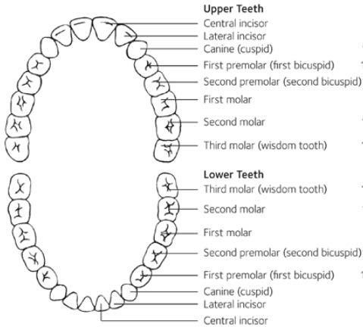

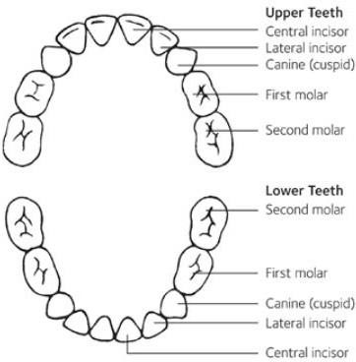

|  |  |
| --- | --- |
| Condition of Mouth: | |
| Number of Fillings: | Number of Extractions: |
| Other necessary work or remarks: | |
| Next Appointment: | |
| Dentist Signature: | |